TopShooter

Game Manual

Yaacov Simmons, Ross Laing, Stefan Ganescu, Aiden Deegan, Iain Forrester

Contents

Introduction 2

Getting Started 2

Default Controls 2

Preparing to Play 2

Options Menu 2

Typical Game Screen 3

Moves and Combat 3

Playing the Game 3

Weapons (N/A) 3

Powerups and Pickups (N/A) 3

Characters 3

Customer Support 4

# Introduction

Welcome to TopShooter, you have found yourself trapped, the only way out is to use the weapon you have been provided by your captor. Do you shoot your way to freedom or become another victim in the endless cycle?

# Getting Started

TopShooter supports mouse and keyboard control systems as well as automatically saving your scores to the system.

## Default Controls

The default controls of TopShooter are the use of the WASD keys for movement of the character and the Space bar to fire the characters weapon. These control schemes may be updated, or additional options may be added in future for further accessibility for those who prefer other ways to play such as controllers.

## Preparing to Play

Upon loading up the home page of TopShooter two button options will appear, these will be Play and Options. This can be seen below:

>>>>> INCLUDE HOME PAGE IMAGE<<<<<<<

When selecting the Play button on the home screen you will be directed to the Login/Register page if you have not already logged into the game. If the user has not registered for the game they will be required to enter their details on the page to become a member and log in to play a game, they will be able to follow the information required on screen and then select submit.

>>>>> INCLUDE LOGIN/REGISTER PAGE IMAGE<<<<<<<

Once a player is logged in, they may press play again and this will put them in in a queue to begin matching with other players before the game begins. The game will automatically begin when enough players are in play.

>>>>> INCLUDE QUEUE PAGE IMAGE<<<<<<<

## Options Menu

In the Options menu the users will be able to alter certain options within the game itself for themselves personally. These options include:

* Controller Setup
* A/V Options
* Accessibility Options

The Controller Setup option will allow users to alter their playing style by letting them set their own default keyboard scheme or in future add controllers to be used.

The A/V Options gives players the ability to decrease or increase the volume of the game and mute if necessary.

The Accessibility Options allow players to alter their character sprites and map colour layouts. This is used for those who have a visual impairment so that they will have easier assess to the game.

## Typical Game Screen

>>>>> INCLUDE GAME PAGE IMAGE<<<<<<<

# Moves and Combat

TopShooter is an action combat game. Playing in a top-down perspective, the players movement within the game will be through the use of the WASD keys on the keyboard and firing the characters weapon will be done using the Spacebar. Players will have the ability to use objects placed on game maps as cover while they consider their next moves or to simply hide from enemy players attacks.

# Playing the Game

During TopShooter the players will be tasked with defeating all player characters on the given map to complete the match. When a player defeats an opponent, their personal score will be added to the leaderboard. Once a match has been completed the players will be returned to the main page and they will be able to press ‘Play’ to begin another game.

# Weapons (N/A)

At the current stage in development there has been no further weapons added to TopShooter, however players can look forward to these improvements being made in future updates.

# Powerups and Pickups (N/A)

At the current stage in development there has been no powerups and pickups added to TopShooter, however players can look forward to these improvements being made in future updates.

# Characters

TopShooter has provided varying sprites for players to choose from using various shapes and colours so as to add accessibility to those players with visual impairments.

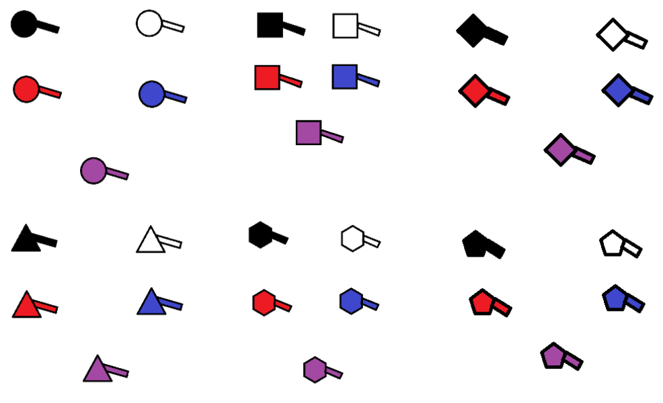

# Customer Support

For any customer support issues please refer to the ‘Contact Us’ page of the TopShooter website.